

**UNIVERSITY OF NAIROBI**

**FACULTY OF SCIENCE AND TECHNOLOGY**

**DEPARTMENT OF COMPUTING & INFORMATICS**

**CIRCULAR ECONOMY SYSTEM**

**By**

**BIKURI ADRIAN MUNENE**

**Registration No: P15/143096/2021**

**Supervisor: Dr. Christopher Chepken**

A project report submitted in partial fulfilment of the requirements for the award of Bachelor of Science in Computer Science of the University of Nairobi

**June 2023**

# Declaration

This project is my original work and, to the best of my knowledge, has not been submitted for any other award in any University.

BIKURI ADRIAN MUNENE: _____________________ Date: _______________

(P15/143096/2021)

This project report has been submitted in partial fulfilment of the requirements for the Bachelor of Science in Computer Science of the University of Nairobi with my approval as the University supervisor.

Dr. CHRISTOPHER CHEPKEN: ____________________________

Date: _______________

Department of Computing and Informatics

# Abstract

The circular economy system is an innovative and sustainable platform designed to facilitate the transition from a linear "take-make-dispose" model to a circular model that promotes resource efficiency, waste reduction, and value creation. This system aims to create a closed-loop economy where products and materials are reused, remanufactured, and recycled, minimizing environmental impact and maximizing economic and social benefits.

The system provides an online marketplace where users can buy and sell a wide range of products, encouraging the exchange of pre-owned goods and promoting the concept of sharing and reuse. It offers a user-friendly interface that allows individuals and businesses to list their products, set prices, and connect with potential buyers. Users can easily search for products based on various criteria and make secure transactions through integrated payment gateways.

To ensure the smooth functioning of the system, robust features are implemented, including inventory management, order tracking, and secure payment processing. Users can track the lifecycle of their products, from listing to sale, and participate in the circular economy by extending the lifespan of goods and reducing waste.

The system also emphasizes community engagement and awareness by providing educational resources, tips for sustainable living, and a forum for users to exchange ideas and experiences. It promotes collaboration among individuals, businesses, and organizations, fostering a culture of sustainability and responsible consumption.

By implementing the circular economy system, businesses can unlock new revenue streams, reduce resource dependence, and enhance their environmental credentials. Individuals can contribute to a more sustainable future by embracing circular practices and making informed purchasing decisions.

# Table of Contents

Contents

Declaration ii

Abstract iii

Table of Contents iv

Table of Figures v

Chapter 1: Introduction 1

1.1. Problem Statement 1

1.2. Objectives 1

1.3. Project Justification 2

Chapter 2: Literature Review 3

2.1. Introduction 3

2.2. Literature Review 3

2.3. Implications 4

Chapter 3: System Analysis and Design 5

3.1. Spiral System Development Methodology 5

3.2. System Analysis 5

3.2.1. Conceptual Framework 5

3.2.2. Requirements Specification 6

3.3. System Design 7

3.3.1. System Architecture Design 7

3.3.2. Database Design 7

3.3.3. User Interface Design 9

Chapter 4: System Implementation 13

4.1. Technologies Used 13

Chapter 5: Conclusion and Recommendations 14

5.1. Conclusions 14

5.2. Recommendations 14

References 15

Appendix A: User Manual 1

Appendix B: Sample Code 4

# Table of Figures

Figure 1: System Architecture 7

Figure 2: Login View 9

Figure 3: Registration View 9

Figure 4: Home View 10

Figure 5: Products View 10

Figure 6: Single Product View 11

Figure 7: Profile View 11

Figure 8: Cart View 12

Figure 9: Sell Product View 12

Figure 10: Registration 1

Figure 11: Login 2

Figure 12: Sell 3

# Chapter 1: Introduction

## Problem Statement

In today's linear economy, resources are extracted, used, and disposed of, leading to significant environmental degradation and resource depletion. There is a growing need to transition towards a circular economy, where resources are kept in use for as long as possible, and waste is minimized. However, individuals and businesses often face challenges in finding and accessing sustainable products, recycling options, and opportunities to participate in the circular economy.

The problem is that there is a lack of a centralized platform that connects individuals, businesses, and organizations involved in the circular economy. This platform would enable users to easily find, buy, sell, and exchange sustainable products, materials, and services. It would also provide information on recycling, upcycling, and other circular practices, fostering a community that promotes sustainable living and supports the circular economy principles.

The circular economy website aims to address this problem by creating an online platform that connects users with sustainable products, facilitates resource sharing and recycling, and promotes awareness and engagement in circular practices. The website will serve as a one-stop destination for individuals and businesses looking to participate in the circular economy, fostering a more sustainable and environmentally conscious society.

## Objectives

* + 1. Research Objectives

1. Assess the current state of the circular economy and identify key challenges and opportunities.
2. Understand the needs and preferences of target users in relation to circular economy practices and solutions.
3. Explore best practices and case studies of successful circular economy initiatives.
4. Analyze the environmental, social, and economic benefits of adopting circular economy principles.
   * 1. System Development Objectives
5. Develop a user-friendly and intuitive website interface that promotes engagement and information dissemination.
6. Implement a robust search and filtering system to allow users to easily find relevant information, products, or services related to the circular economy.
7. Create a secure and scalable database system to manage user profiles, product listings, and transactions.

## Project Justification

The project justification for the Circular Economy System is based on two key factors:

1. Environmental Impact

The current linear economy model is leading to resource depletion, waste generation, and environmental degradation. The circular economy promotes sustainable practices such as recycling, reusing, and reducing waste. The website aims to facilitate the transition to a circular economy by providing a platform for users to exchange products, promote sustainable consumption, and reduce environmental impact.

1. Economic Benefits

The circular economy offers significant economic opportunities, including job creation, cost savings, and improved resource efficiency. The website can stimulate economic growth by enabling businesses and individuals to participate in circular practices, such as selling or donating unused items, promoting local production, and fostering collaborations.

# Chapter 2: Literature Review

## Introduction

The literature review explores existing research related to the implementation of circular economy principles. It aims to inform the development and effectiveness of the circular economy website in promoting sustainable consumption and waste reduction.

## Literature Review

Based on the research objectives:

1. Assess the current state of the circular economy and identify key challenges and opportunities.

**Circular Economy: Opportunities and Challenges (Geissdoerfer et al., 2017)**

"The circular economy (CE) offers opportunities to achieve economic growth while reducing resource consumption and environmental impacts. However, challenges such as shifting business models, technological advancements, and policy support need to be addressed to realize the full potential of the circular economy."

1. Understand the needs and preferences of target users in relation to circular economy practices and solutions.

**Consumer Preferences and Behavior Towards Product Circular Economy (Lüdeke-Freund et al., 2018)**

"Consumers' preferences towards circular economy practices are influenced by factors such as environmental consciousness, cost savings, and product quality. Understanding these preferences is crucial for designing effective circular economy solutions that align with consumer needs and motivations."

1. Explore best practices and case studies of successful circular economy initiatives.

**The Circular Economy: New Opportunities in the Metal Industry (Hauschild et al., 2018)**

"The metal industry has witnessed successful circular economy initiatives through practices like recycling, remanufacturing, and product life extension. These initiatives have not only reduced environmental impact but also created new business opportunities and enhanced resource efficiency within the industry."

1. Analyze the environmental, social and economic benefits of adopting circular economy practices.

**Environmental and Economic Benefits of the Circular Economy in Europe (European Environment Agency, 2019)**

"The circular economy has the potential to significantly reduce greenhouse gas emissions, minimize waste generation, and conserve natural resources. It also offers economic benefits by promoting innovation, job creation, and increased competitiveness, contributing to a more sustainable and resilient economy."

## Implications

1. The project should focus on addressing the key challenges identified in the circular economy. This may involve developing strategies to overcome barriers related to business models, technology integration, and policy support.
2. User needs and preferences should be carefully considered when designing the website. The project should incorporate features and solutions that align with consumer motivations, such as environmental consciousness, cost savings, and product quality.
3. Learning from successful case studies and best practices is essential. The project should draw inspiration from successful circular economy initiatives, particularly in industries like metal recycling, remanufacturing. These examples can provide insights into effective strategies and business models.
4. The project should emphasize the environmental, social, and economic benefits of adopting circular economy principles. Highlighting the positive impacts, such as reduced greenhouse gas emissions, waste reduction, and resource conservation, can help promote the importance of circular economy practices to users and stakeholders.

# Chapter 3: System Analysis and Design

## Spiral System Development Methodology

The spiral system development methodology is a suitable approach for the development of the circular economy website. This methodology follows an iterative and incremental process that allows for continuous refinement and adaptation of the system based on user feedback and changing requirements. Here is how the spiral methodology can be applied to the development of the circular economy website:

1. Determine Objectives.
2. Risk Analysis.
3. Prototype Development.
4. Evaluation and Feedback.
5. Design and Development.
6. Testing and Quality Assurance.
7. Deployment and User Adoption.
8. Continuous Improvement.

The spiral system development methodology allows for flexibility, adaptability, and ongoing improvement.

## System Analysis

### Conceptual Framework

1. Circular Economy Principles: The core of the conceptual framework revolves around the principles of the circular economy, such as reducing waste, promoting recycling, and reusing products.
2. User Interactions: Users interact with the website through various functionalities, including browsing products, adding items to the cart, and making payments.
3. Product Listings and Categories: The website provides listings of various products categorized into different sections based on their nature, recyclability, or sustainability.
4. Shopping Cart and Checkout: Users can add selected products to the shopping cart, review their selections, and proceed to the checkout for payment.
5. Search and Filtering Options: The system offers search and filtering features to help users find specific products based on keywords, recyclability, or sustainability criteria.
6. User Accounts and Profiles: Users can create accounts and profiles, enabling them to track their order history, manage preferences, and receive personalized recommendations.
7. Payment Gateway Integration: The system integrates secure payment gateways to allow users to make payments using various methods, such as mobile money or credit cards.
8. Order Processing and Fulfillment: After successful payment, the system processes orders and coordinates with sellers or logistics partners for product delivery.
9. Feedback and Reviews: Users can provide feedback and reviews for products, encouraging transparency and accountability among sellers.

### Requirements Specification

**Functional Requirements**

1. User Registration: Allow users to create an account and provide necessary information.
2. Product Listing: Display a list of available products with their details.
3. Shopping Cart: Enable users to add products to their cart, update quantities, and remove items.
4. Payment Processing: Provide options for users to make payments securely using M-Pesa or card.
5. Order Management: Allow users to view and track their orders, view order history, and receive order confirmation.

**Non-Functional Requirements**

1. Performance: The website should load quickly and handle multiple concurrent users without significant performance degradation.
2. Usability: The website should have an intuitive and user-friendly interface, allowing users to easily navigate, search for products, and complete transactions.
3. Security: The website should implement robust security measures to protect user data, prevent unauthorized access, and ensure secure payment processing.
4. Reliability: The website should be highly available, with minimal downtime and the ability to recover from failures.
5. Scalability: The system should be scalable to accommodate future growth in terms of user traffic, product catalog, and transactions.

## System Design

### System Architecture Design

Figure : System Architecture

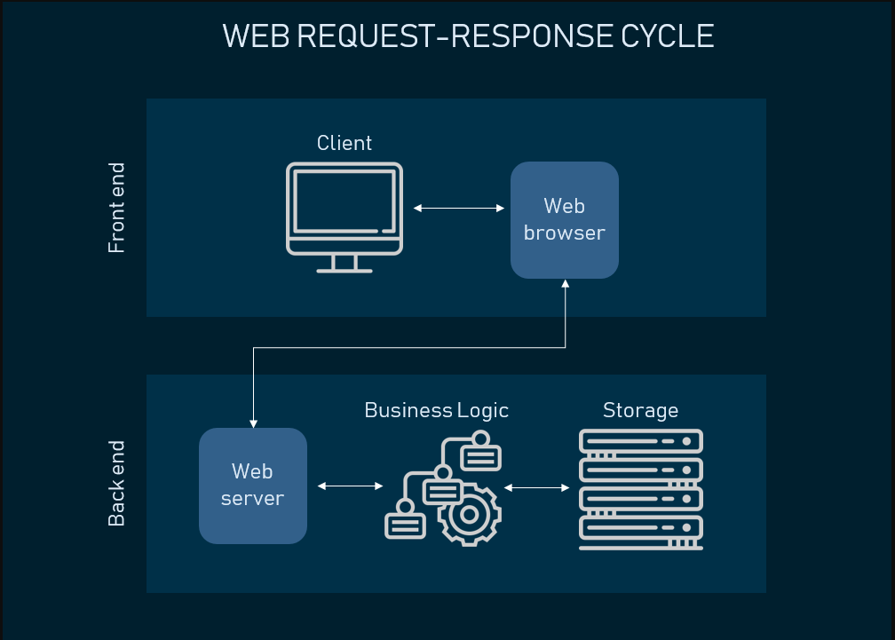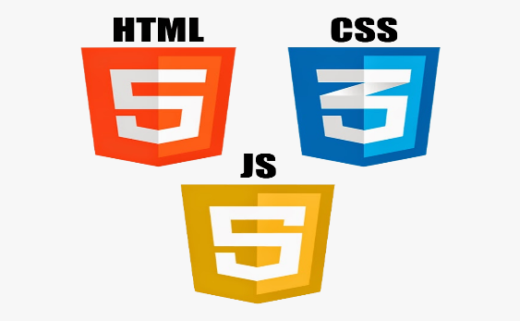

CSS

HTML

JS



### Database Design

The design of the database as described by the schema below

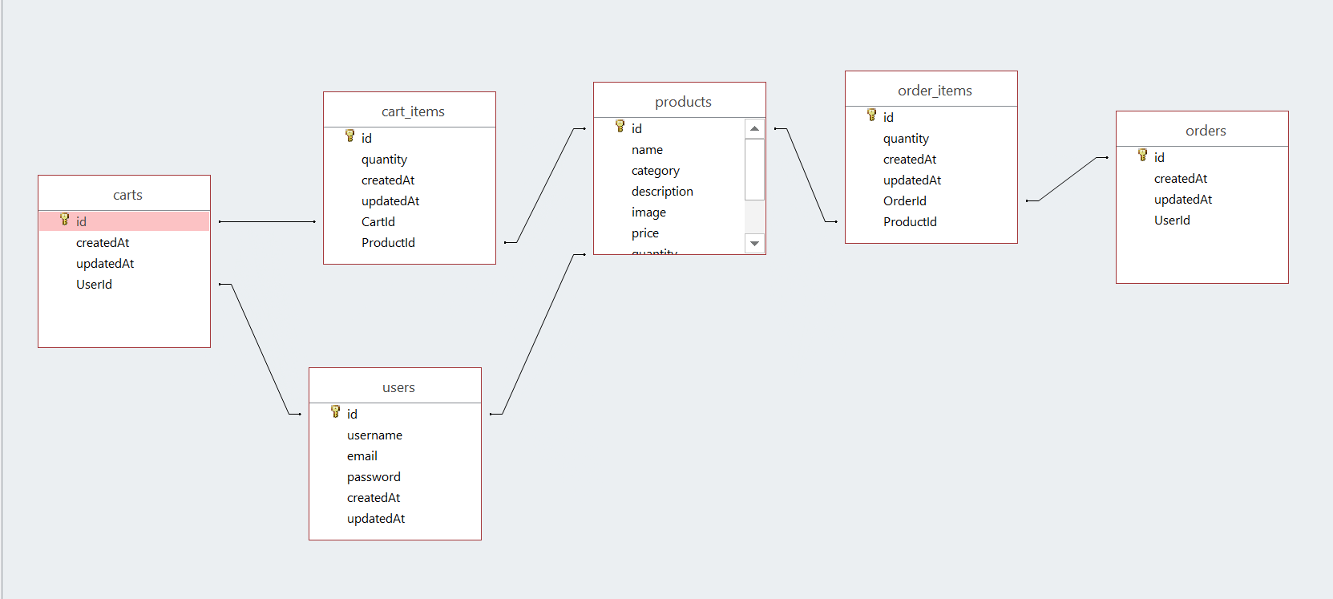

**Frontend**

Pug a HTML view engine to create the Document Object Model, i.e. the elements displayed on a page

CSS to manipulate the DOM and style page elements according to a specific theme.

JavaScript, to create a responsive and interactive website.

**Backend and Business Logic**

Node-JS to implement business logic by routing user requests to functions that complete them.

**Storage**

MySQL Database to store records of:

1. Users – User information i.e. email, password for login and registration purposes

User cart items

User orders and order history

1. Products – Details of products posted on the site for sale.

### User Interface Design

**Login and Registration Pages**

**Login View**

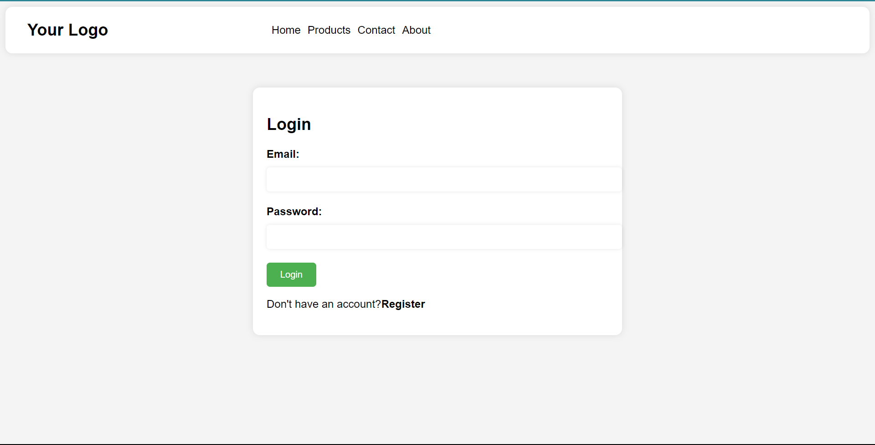

Figure : Login View

**Registration View**

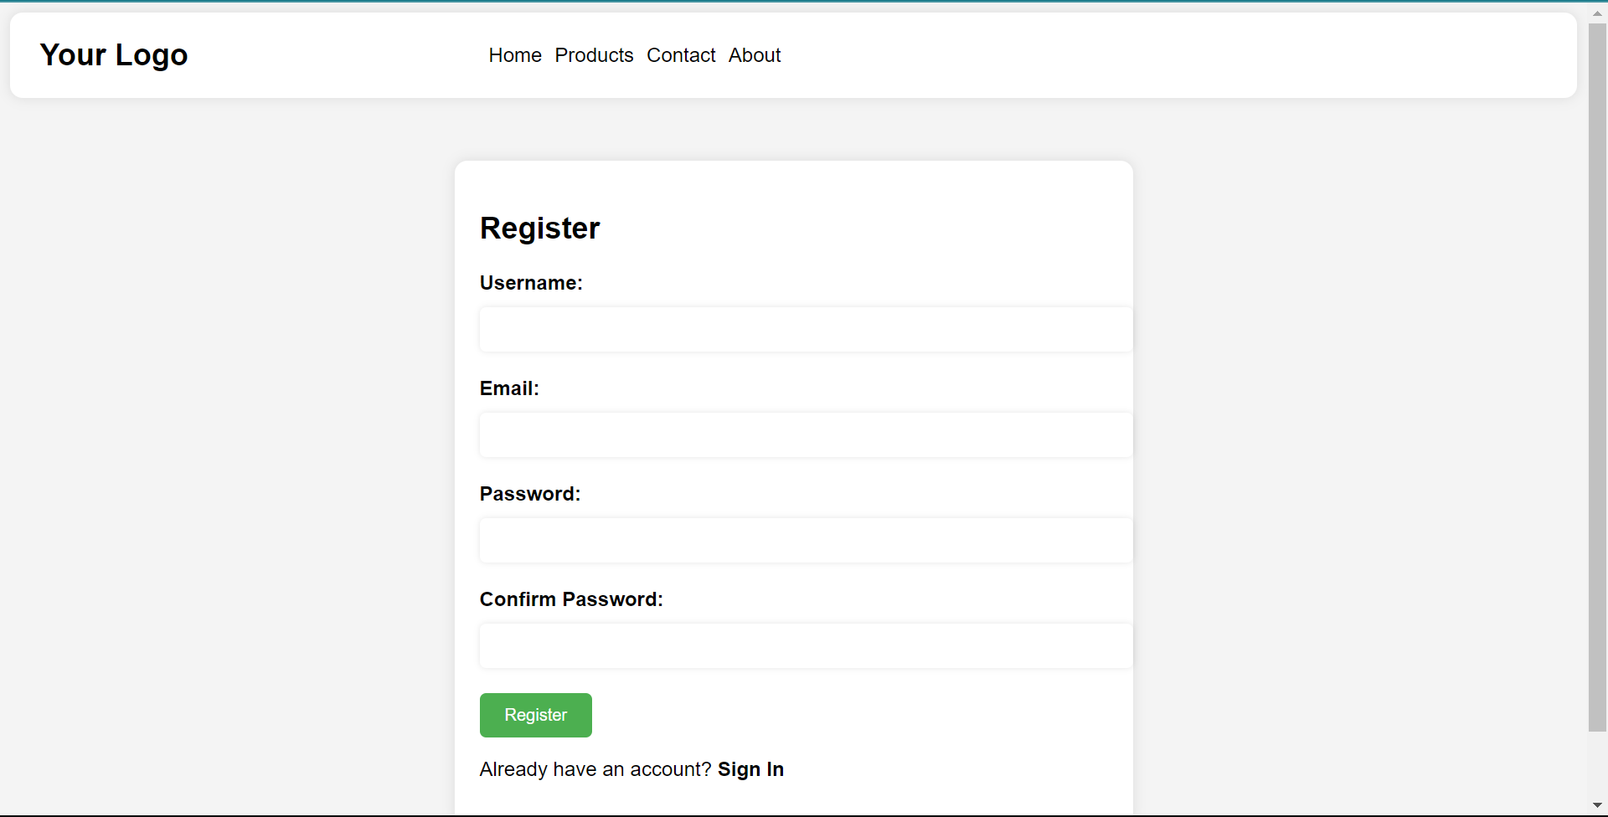

Figure : Registration View

**Content Pages**

**Home View**

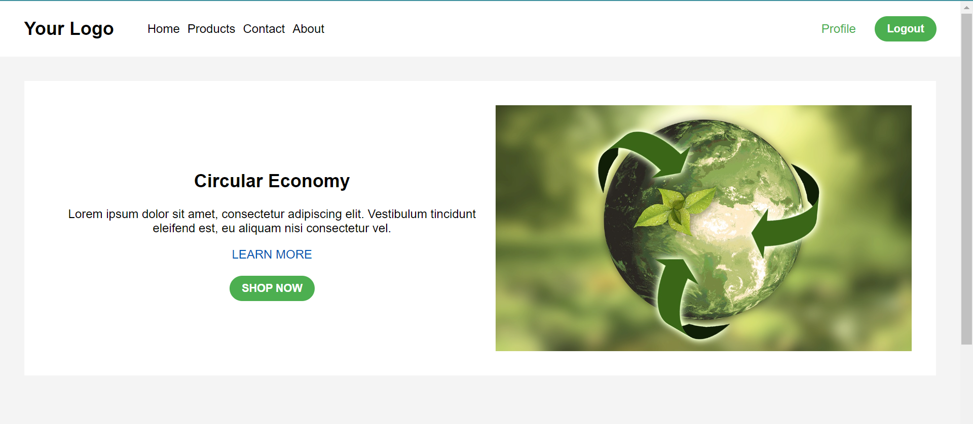

Figure : Home View

**Products View**

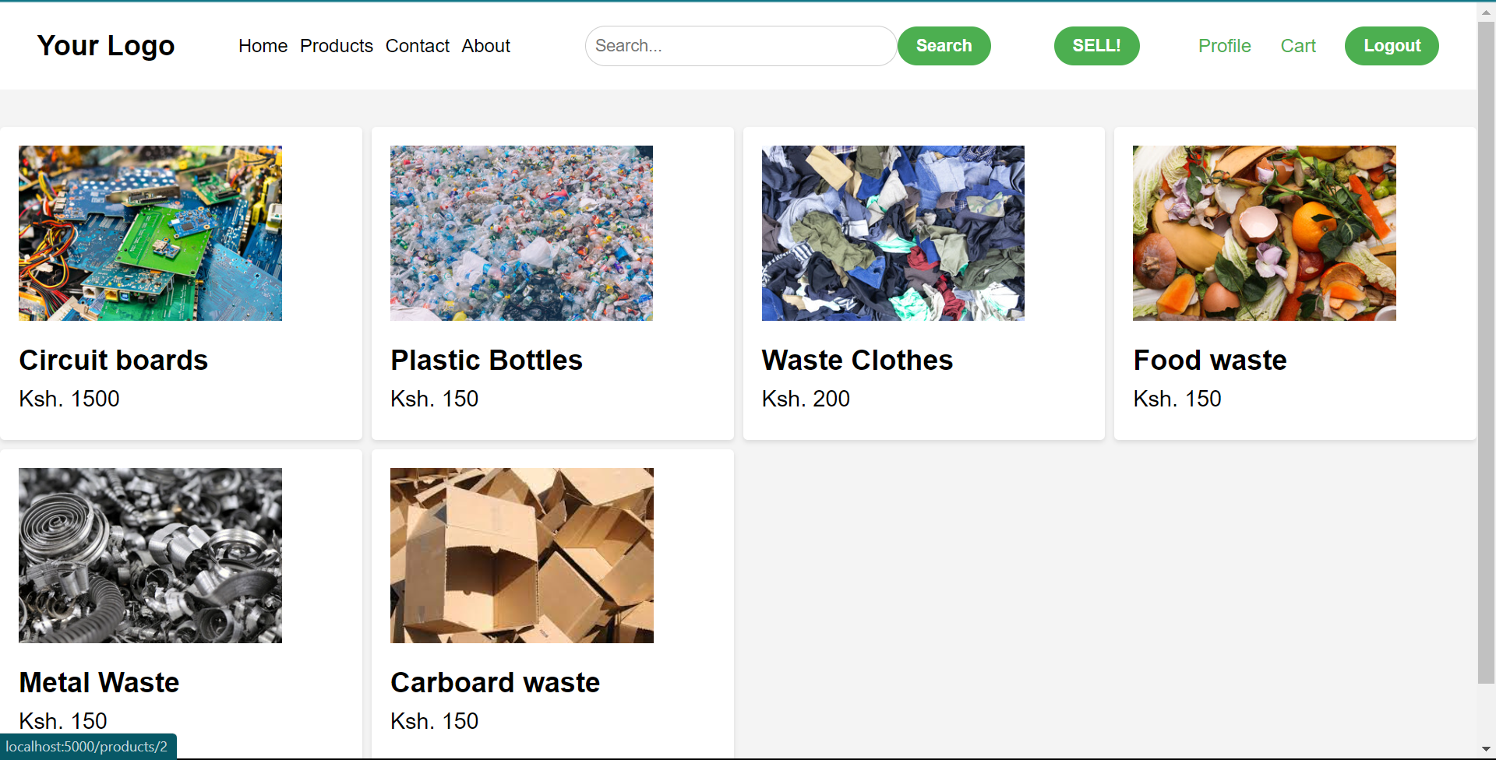

Figure : Products View

**Single Product View**

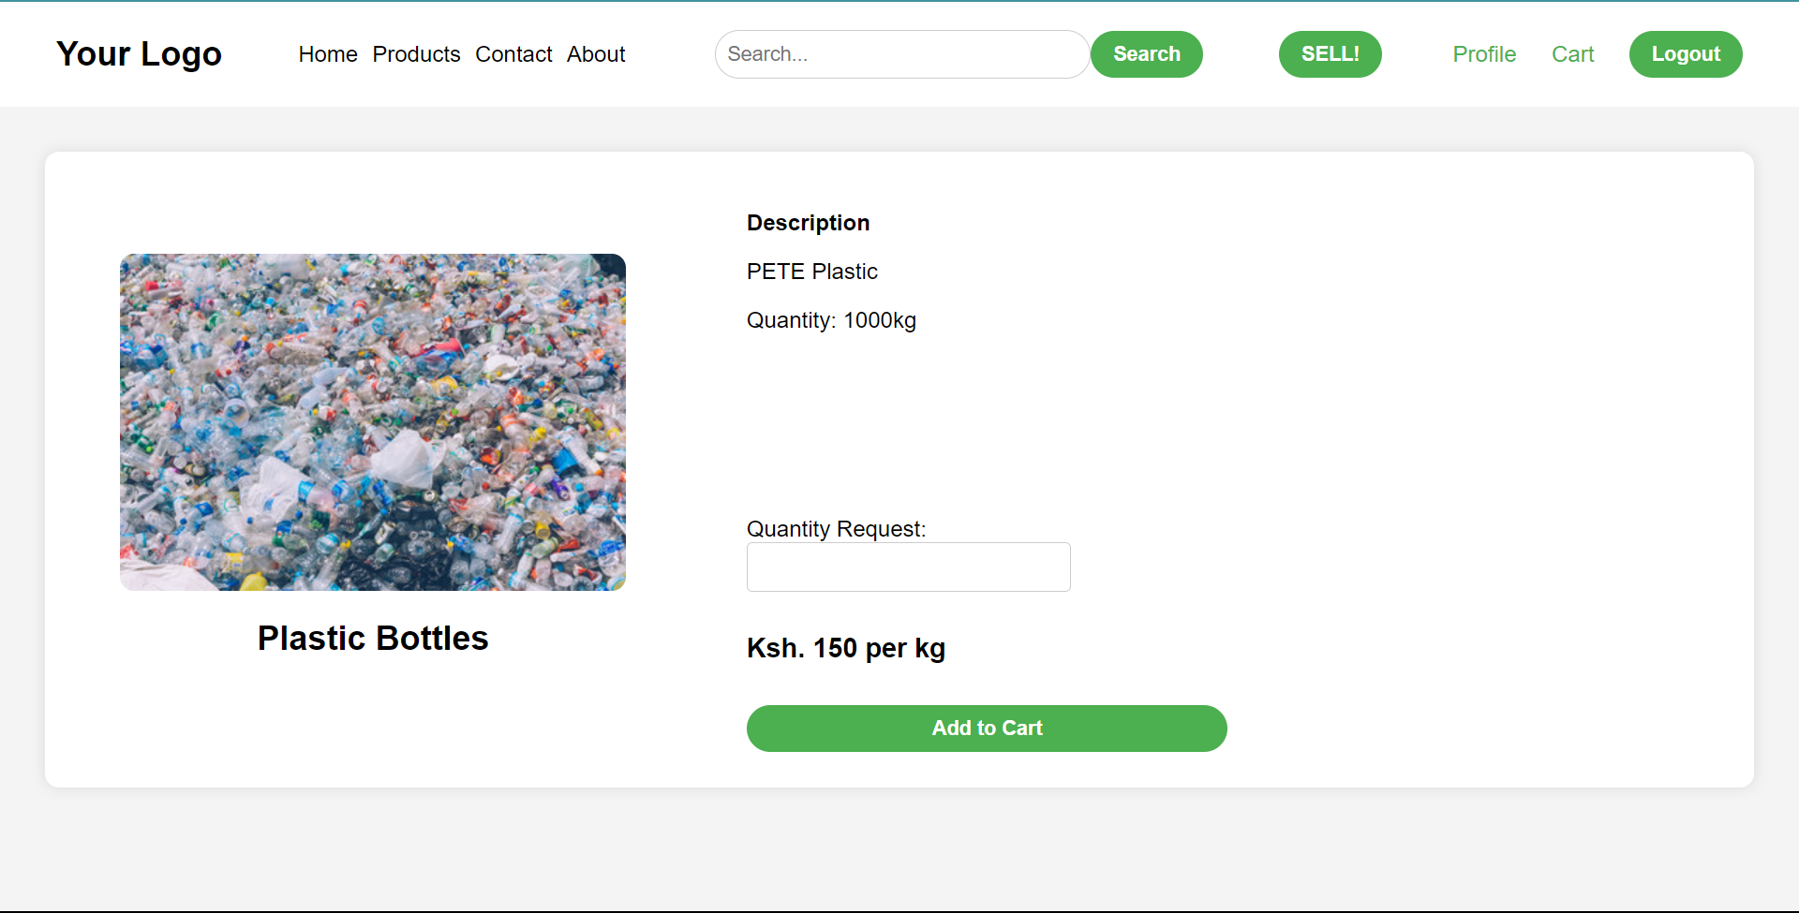

Figure : Single Product View

**Profile View**

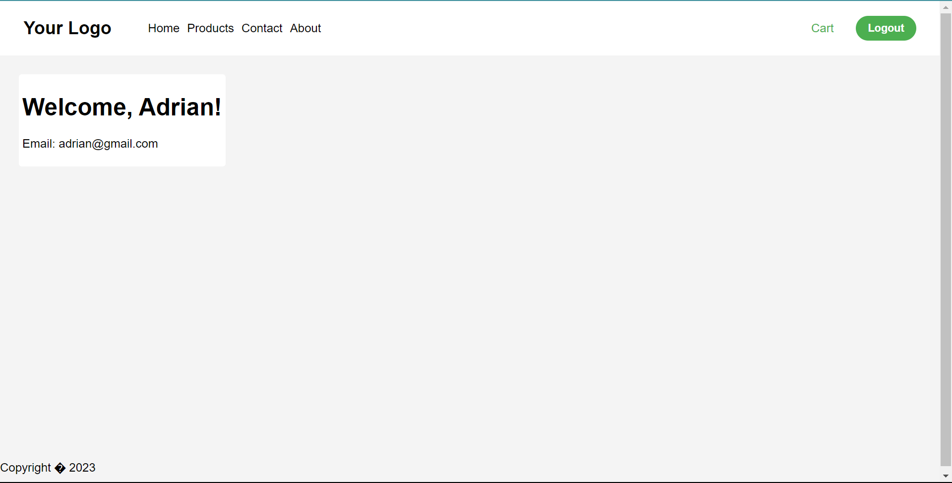

Figure : Profile View

**Cart View**

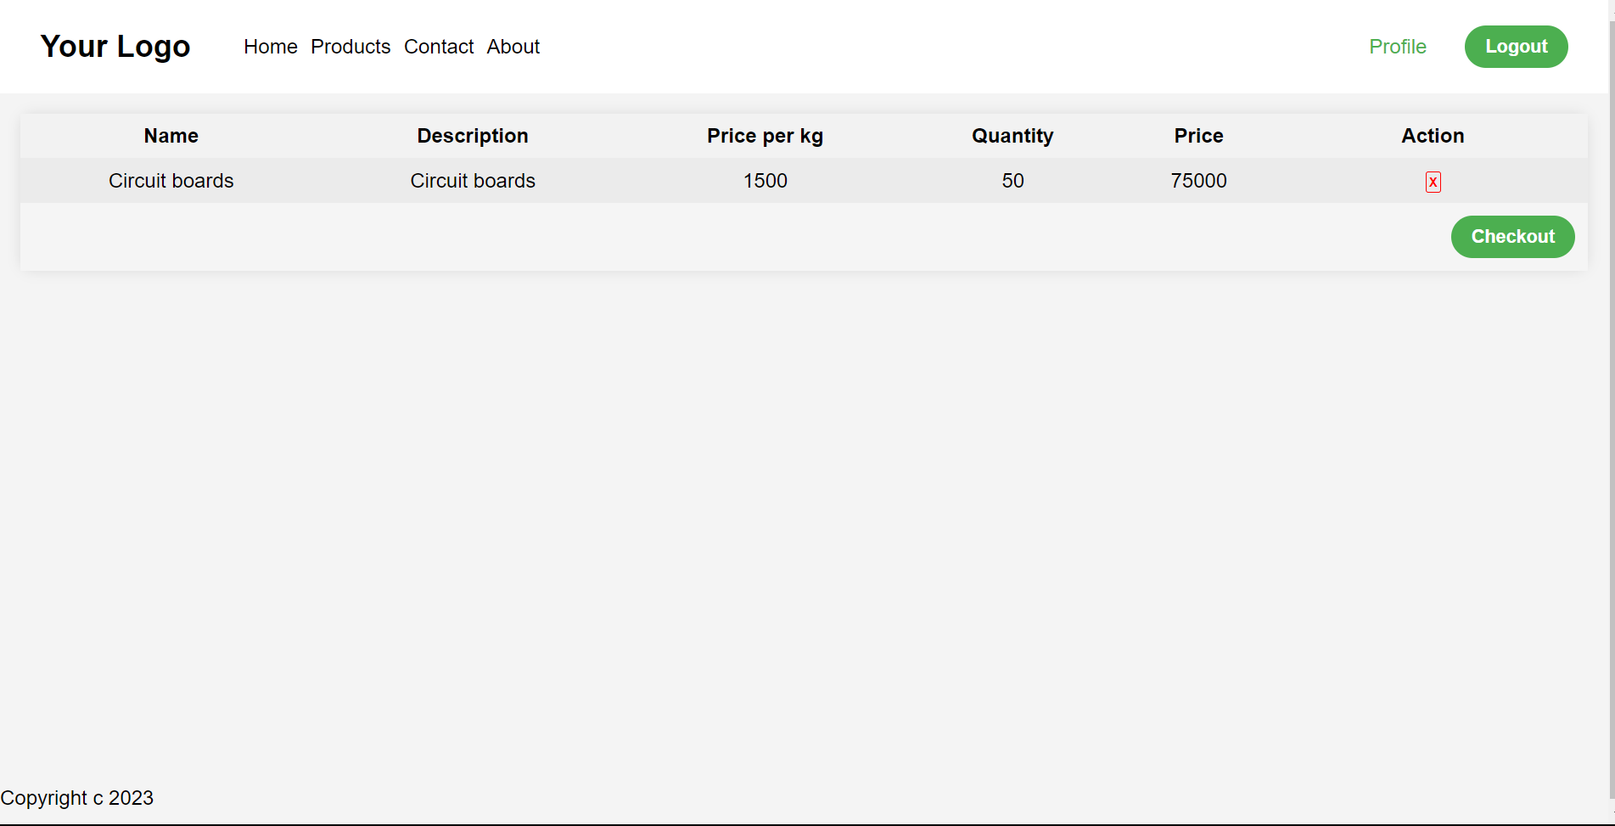

Figure : Cart View

**Sell Product View**

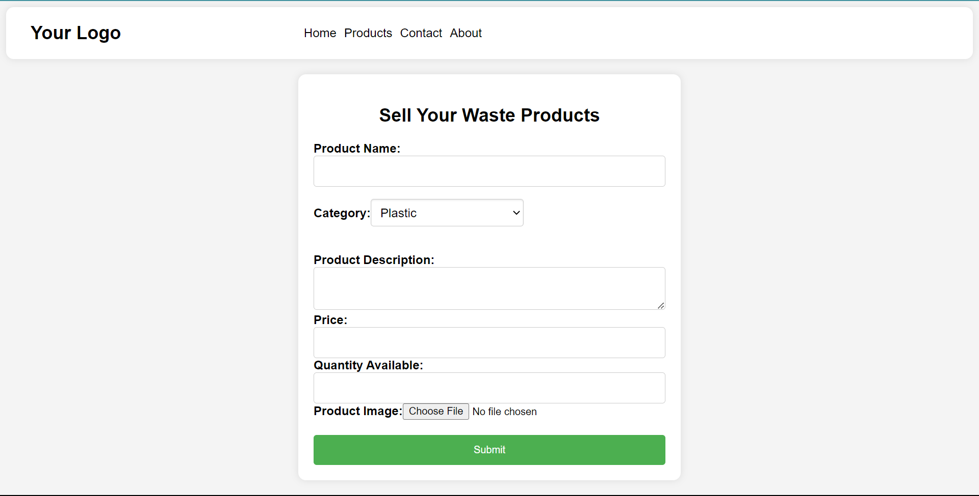

Figure : Sell Product View

# Chapter 4: System Implementation



## Technologies Used

1. Node JS – A server-side runtime environment that is used to fulfill user requests by running the JavaScript code that handles the business logic.
2. Pug view engine (HTML) – A HTML view engine used to create HTML web pages.
3. Cascading Style Sheets, CSS – Style the HTML web pages.
4. MySQL – Open source relational database management system used with MySQL Shell to manage the circular economy website database.
5. Visual Studio Integrated Development Environment – Source code editor by Microsoft used to manage the project’s code files, write, and edit code.
6. Git Version Control – To manage source code by tracking changes in code.
7. Microsoft Word – Create project documentation.
8. Google Chrome Web Browser – Display the project’s web pages and used to test routes by handling user requests.

# Chapter 5: Conclusion and Recommendations



## Conclusions

Based on the research conducted, it is evident that implementing a circular economy through the creation of a website holds significant potential for promoting sustainable practices and driving positive environmental, social, and economic outcomes. The literature reviews highlighted key challenges, user preferences, successful initiatives, and the benefits of circular economy principles. This information provides a strong foundation for the project, emphasizing the need to address challenges, align with user needs, learn from best practices, and highlight the benefits of circular economy practices.

## Recommendations

1. Develop a user-centric website: Prioritize user needs and preferences when designing the website, ensuring a user-friendly interface, intuitive navigation, and personalized experiences that promote engagement and adoption of circular economy practices.
2. Provide comprehensive information and resources: Ensure the website offers comprehensive information on circular economy concepts, practices, and available resources. This can include case studies, guidelines, toolkits, and educational materials to empower users with knowledge and support their transition to circular economy practices.
3. Continuously update and improve the website: Stay up to date with emerging trends, technologies, and best practices in the circular economy field. Regularly update the website's content, features, and functionalities to provide users with relevant and innovative solutions, ensuring its long-term effectiveness and value.

# References

Chat GPT

Other references have been sited within the document

# Appendix A: User Manual

**Registration**

1. Press the log in button on the top right of the screen. This will redirect you to the log in page
2. On the login page, at the bottom click the “Create an account” text to redirect to the registration page.
3. Fill in the details in the provided spaces and click submit to redirect to the login page.
4. Log in with the account you’ve created.



Figure : Registration

**Login**

1. Click log in on the navigation bar to redirect to the log in page
2. Enter account details and click the log in button.



Figure : Login

**Sell**

1. Navigate to the products page
2. Click the SELL button on the navigation bar
3. Fill in the details of the product you want to sell and click submit



Figure : Sell

# Appendix B: Sample Code

**Add to Cart Functionality**

The following code allows the user to complete the add to cart route, that allows a user to add a product to his/her cart by completing the /addtoCart route

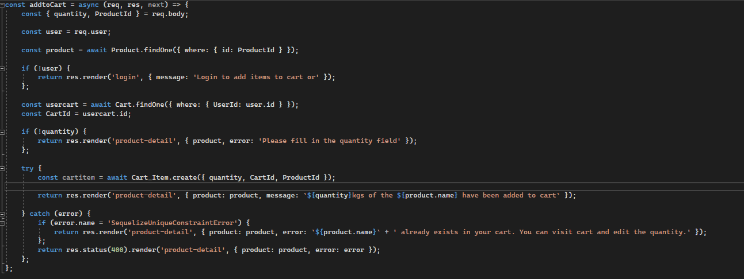

**Display Products**

The following code is used to dynamically display products on the product page by completing the /products route.

